Software Analysis & Testing

- Total tests: 6, Passed: 4, Failed: 2

- Log table
ID | File | Line | Description | Suspected Severity
1 | tasks.py | 48 | get_pending_tasks() loops from index 1 so task at index 0 is never included
2 | tasks.py | 59 | Average_priority() has a for loop which divided total which is divided by number of tasks, zero tasks will cause a crash.
3 | storage.py | 12 | format_task_report() concatenates an integer ID with strings causing a TypeError
4 | tasks.py | 17 & 23 | save_tasks() and add_task() are imported but never read
5 | task.py | 26 | len(tasks) + 1  will cause tasks to be duplicated
6 | storage.py | 4 | API_KEY is stored in source code
7 | tasks.py | 8 | Opens the file without closing
8 | Remove_task() | 64 | Gives no indication that the removal was successful

- Installed tool versions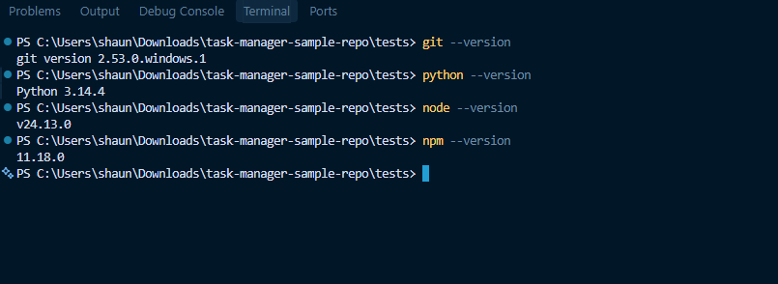
- AI assistant


